REF | 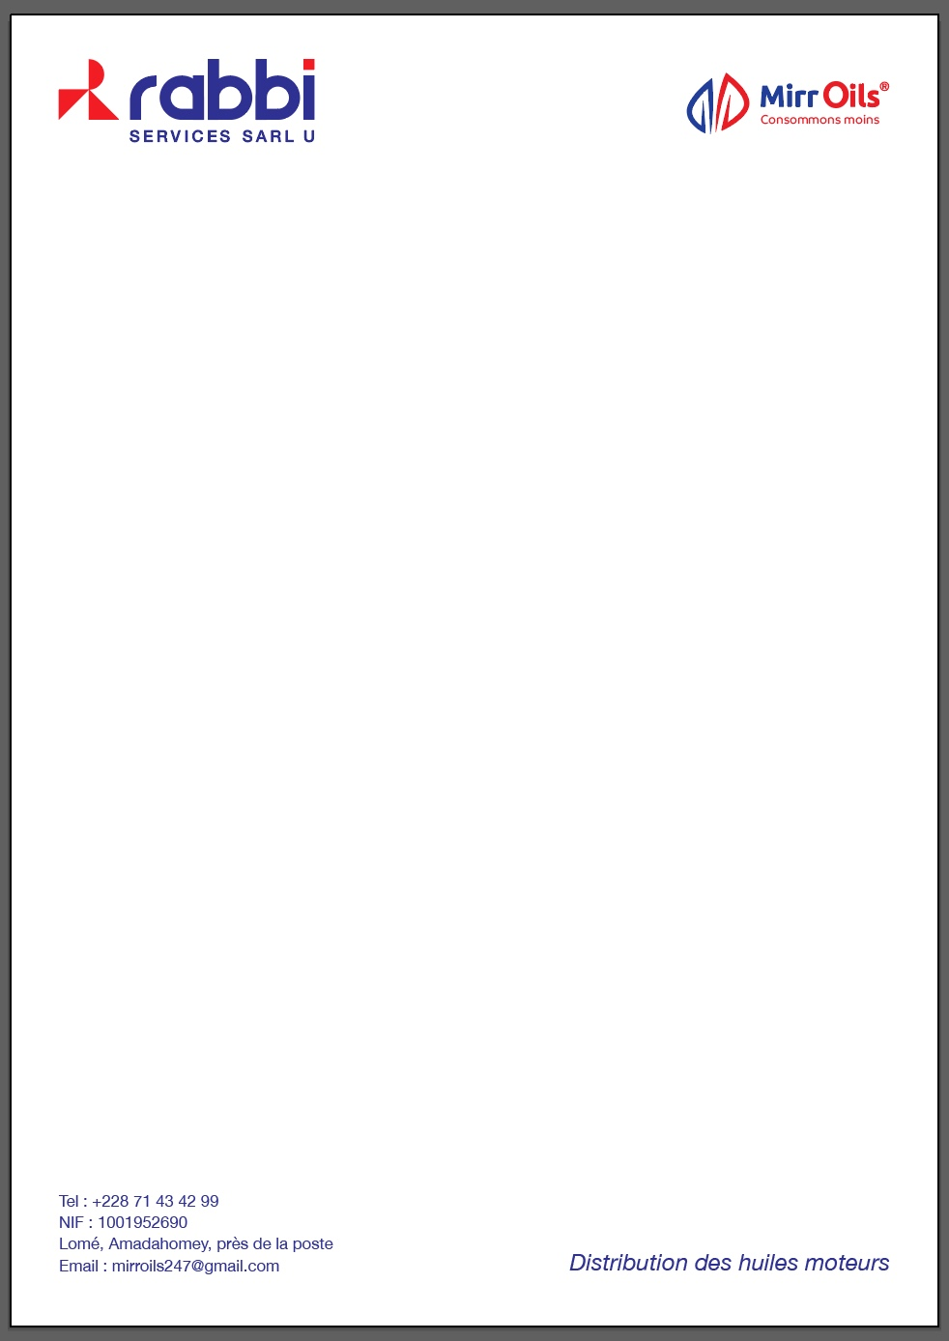  DESCRIPTION OF GOODS | QTE | QTE/CTN | PRIX MECANO | PRIX SEMI-DISTRIBUTEUR | PRIX DISTRIBUTEUR | PRIX CONSOMMATEUR
1 | Mirr ALMA ULTRA API SN SAE 0W-20 (4X5L) | Bidon de 5L | 4 | 24000 | 23 000 | 22000 | 28000
2 | Mirr alma ultra-API SN SAE 0W-30 (4x5L) | Bidons de 5L | 4 | 25 500 | 25 000 | 24 500 | 30 000
3 | Mirr ALMA ULTRA API SN SAE 0W-40 (4X5L) | Bidon de 5L | 4 | 29 000 | 28 000 | 27 000 | 35 000
4 | Mirr ALMA ULTRA API SN SAE 5W-20 (4X5L) | Bidon de 5L | 4 | 25 500 | 25 000 | 24 500 | 29 000
5 | Mirr ALMA ULTRA API SN SAE 5W-30 (4X5L) | Bidon de 5L | 4 | 22 000 | 21 000 | 20 000 | 24 200
6 | Mirr ALMA ULTRA API SN SAE 5W-30 (4X4L) | Bidon de 5L | 4 | 17600 | 16 800 | 16 000 | 19 360
7 | Mirr ALMA ULTRA API SN SAE 5W40 (4x4L) | Bidon 4L | 4 | 21000 | 20 000 | 19 000 | 23 200
8 | Mirr ALMA ULTRA API SN SAE 10W30 (4 x4L) | Bidon 4L | 4 | 18 000 | 17 250 | 16 500 | 19 500
9 | Mirr ALMA ULTRA API SN SAE 10W40 (4 x4L) | Bidon 4L | 4 | 14 850 | 14025 | 13200 | 16500
10 | Mirr Alma super API SN SAE 15W-40 (4x5L) | Bidon 5L | 4 | 14 300 | 13 600 | 13000 | 15000
11 | Mirr Turbo api ch-4 SAE 15W-40 | Bidon 5L | 6 | 14 850 | 14 025 | 13 200 | 16 000
12 | Mirr Turbo api ci-4 SAE 15W-40 | Bidon de 5L | 6 | 14 490 | 13 685 | 12 880 | 15 800
13 | Mirr X DEO API CF-4 SAE 15W-40 (4X5L) | Bidon de 5L | 4 | 14 500 | 13 500 | 12 500 | 15 950
14 | Mirr TURBO PLUS HD DEO API CI-4 SAE 15W-40 (200L) | Drum 1 | 1 | 530 000 | 506 000 | 475 000 | 583 000
15 | Mirr Xdeo api cf SAE 50 (4X5L) | Bidon 5L | 4 | 13 230 | 12 495 | 11 760 | 14 200
16 | Mirr X DEO API CF-4 SAE 50(20L) | Bidon de 20L | 1 | 51 000 | 48 500 | 47 000 | 56 100
17 | Mirr X DEO API CF-4 SAE 50 (20L) | Seau 20L | 1 | 51 000 | 48 500 | 47 000 | 56 100
18 | Mirr X DEO API CF-4 SAE 50-(200L) | Drum 1 | 1 | 462 000 | 438 000 | 415 000 | 508 200
19 | Mirr Xdeo api cf SAE 20W50 (4X5L) | Bidon 5L | 4 | 12 250 | 11 750 | 10 750 | 12 750
20 | Mirr Xdeo api cf SAE 20W50 (200L) | Drum 1 | 1 |  | - | 390 000 | -
21 | Mirr T-Cross 4T API SL SAE 20W-50 (24X1L) | Bidon de 1L | 24 | 2 900 | 2 700 | 2 200 | 3 200
22 | Mirr T-Cross 4T API SL SAE 20W-50 (20L) | Bidon de 20L | 1 | 52 000 | 51 000 | 50 000 | 57 200
23 | Mirr T-Cross 4T API SL SAE 20W-50 (200L) | Drum 1 | 1 | 464 000 | 440 000 | 417 000 | 510 400
24 | Mirr T-Cross 2T (200L) | Drum 1 | 1 | 478 700 | 453 500 | 428 300 | 526 550
25 | Mirr SHIFT ATF DEX III | Bidon de 1L | 12 | 4 770 | 4 505 | 4 240 | 5 300
26 | Mirr Shift ATF DEX III (4X5L) | Bidon de 5L | 4 | 24 000 | 23 000 | 22 000 | 26 400
27 | Mirr Shift ATF DEX VI (4X5L) | Bidon de 5L | 4 | 26 500 | 25 500 | 24 500 | 29 150
28 | Mirr Shift ATF DEX III (200L) | Drum 1 | 1 | 830 000 | 780 000 | 770 000 | 913 000
29 | Mirr brake fluid dot-3 | 500ml | 24 | 2 250 | 2 125 | 2 000 | 2 500
30 | Mirr brake fluid dot-4 | 500ml | 24 | 2 880 | 2 720 | 2 560 | 3 200
31 | Mirr Lituplex -3 (12x1Kg) | Boîte 1kg | 12 | 5000 | 4800 | 4500 | 5300
32 | Mirr Lituplex -3 (15kg) | Seau 15Kg | 1 | 75 000 | 72 000 | 67500 | 79 500
33 | Mirr Thrust Hydraulic ISO 68 (1L) | Bidon de 1L | 12 | 4250 | 4000 | 3900 | 4500
34 | Mirr Thrust Hydraulic ISO 68 (20L) | Seau 20L | 1 | 85 000 | 80 000 | 78 000 | 90 000
35 | Mirr Coolant 33% (4x4L) | Bidon 4L | 4 | 5000 | - | 4200 | 6000
36 | Mirr GLO api gl-5 SAE 75W-80 | Bidon de 1L | 12 | 3 150 | 2 975 | 2 800 | 3 200


